|  |  |
| --- | --- |
| **TEAM ID** | PNT2022TMID31875 |
| **Project Name** | IOT based safety gadget for child safety monitoring and notification |

Create A Database In Cloudant DB

Aim: To create a database in Cloudant DB to store location data.

Steps followed:

* Logged in to IBM Cloud account
* Navigated to `./resource.
* Clicked on the “Create Resource +” button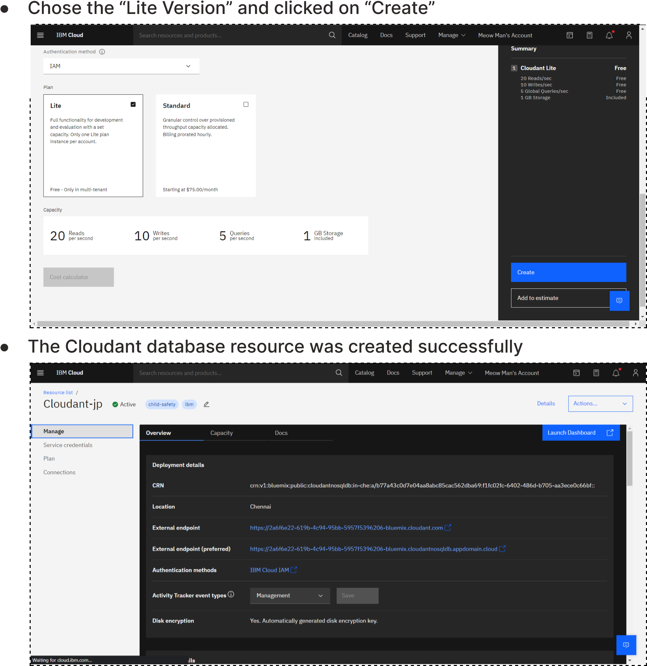
* Searched for “Cloudant”
* Clicked on the “Create Resource +” button
* Searched for “Cloudant”
* Clicked on “Create Database”. Entered “meowman” as the database name and the “Non-partitioned” option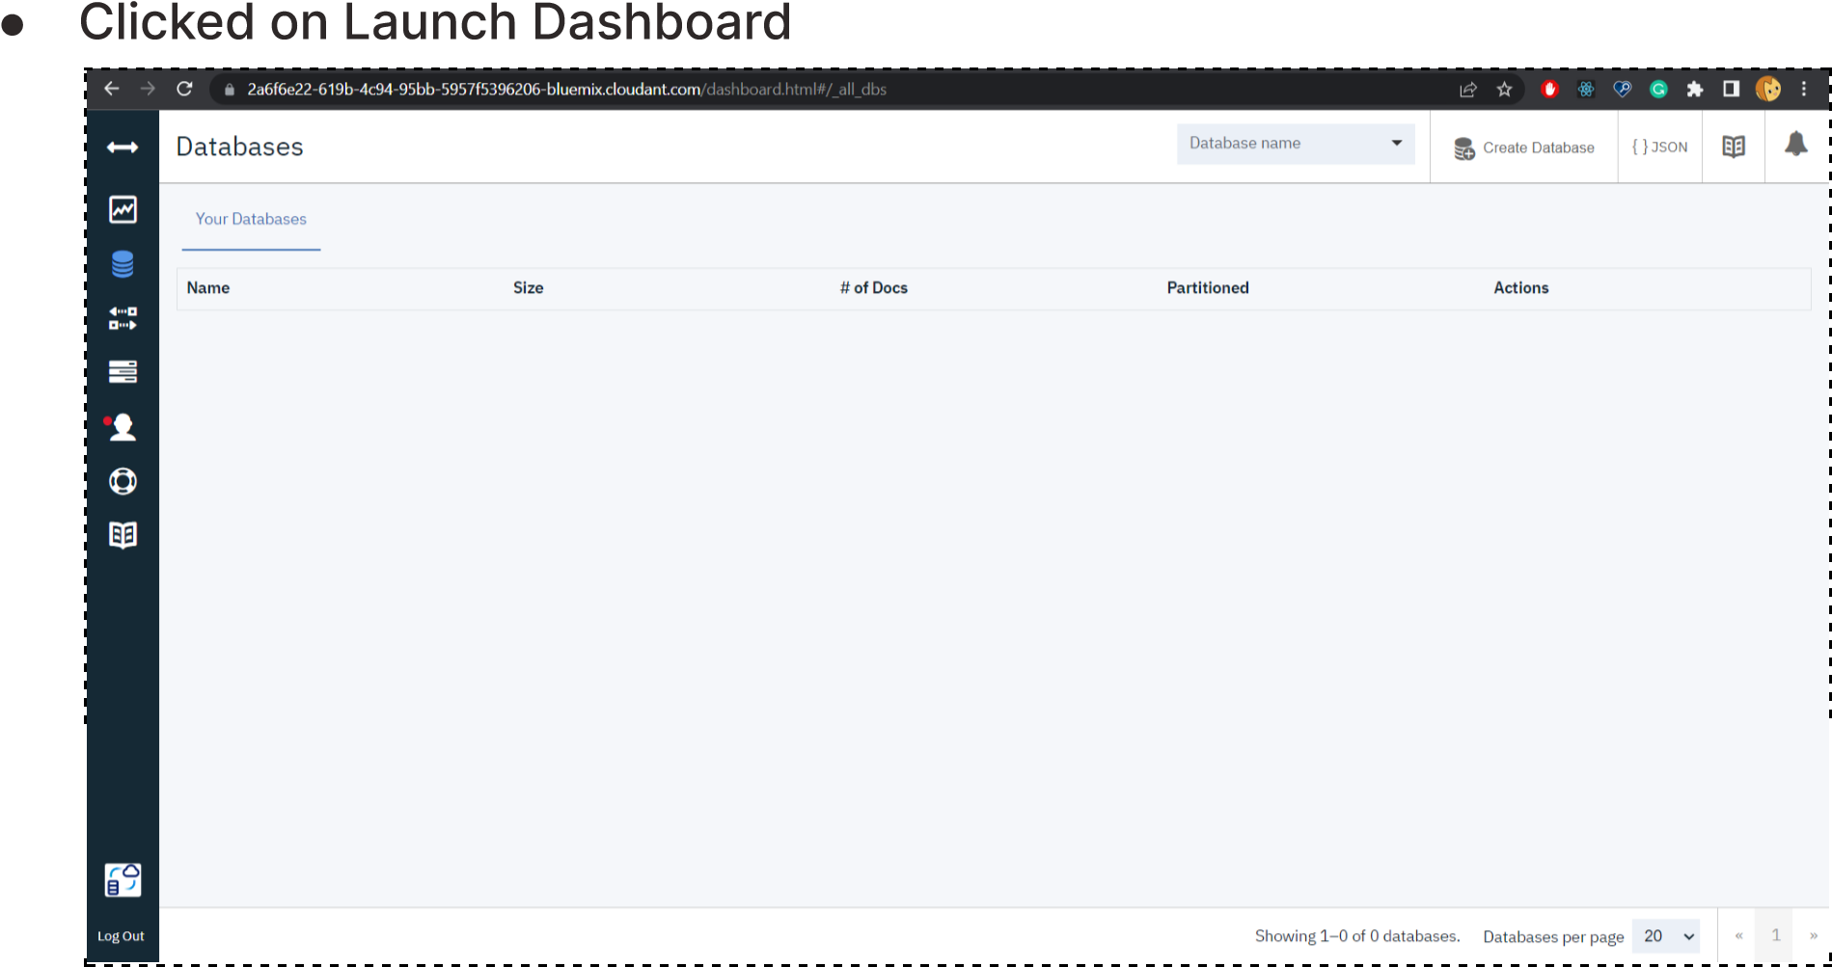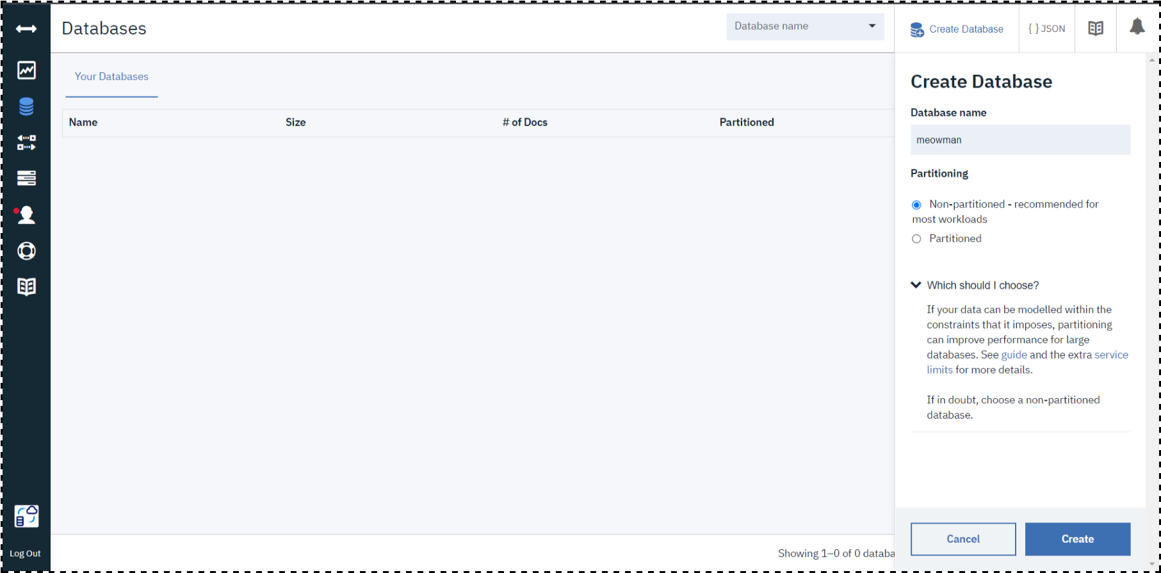

Result:

A database to store the location data was created successfully on Cloudant DB